Vinduino Manual

Draft version July 30,2016

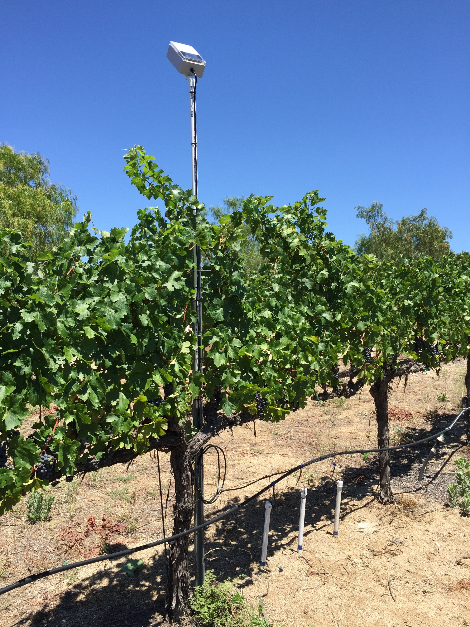

Table of contents

Introduction 3

Scope 3

Sensors 3

Sensor installation 5

Vinduino R3, remote sensor station 6

Solar power 6

Connecting sensors 6

Timer 7

LM-210 radio module 8

Programming 8

Vinduino R3 installation 9

Vinduino Gateway V1 9

Vinduino Gateway Installation 9

ThingSpeak website 10

# Introduction

The award winning Vinduino project is a volunteer-driven, non-commercial project.

The project started out of necessity to better manage irrigation in vineyards. However, it’s application widened to range from home landscaping to agriculture.

It uses low cost, easy to use components, like the popular Arduino microcontroller, supports low-cost gypsum soil moisture sensors, and latest state-of-the-art long range wireless network technology. In order to be of the greatest possible use to the public, the Vinduino project is open source, meaning that the build plan details and software are available in the public domain.

# Scope

This user manual covers use and installation of the Vinduino R3 remote sensor station and the Vinduino Gateway

# Sensors

The Vinduino R3 is designed to support up to 4 resistive soil moisture sensors. These can be gypsum sensors, which are easy to make yourself, or commercial sensors like the Watermark SS200 granular matrix sensor.

The Vinduino design uses short electrical pulses to measure the resistance of the sensor, which is a measure of the water content of the soil. A low resistance indicates high water availability, whereas a high resistance value indicated low water availability.

The resistance is expressed in Ohm, and can be used in combination with a calibration chart to determine water content. A calibration chart for the Vinduino gypsum sensors is being developed and improved as ongoing part of the project.

For Watermark SS200 sensors, calibration is well documented (Shock et all) and available on-line: <http://www.kimberly.uidaho.edu/water/swm/Calibration_Watermark2.htm>

Apart from soil moisture sensors, the Vinduino remote sensor station has the option to support other types of sensors. Here is a list of sensors that have been tested to work with the Vinduino:

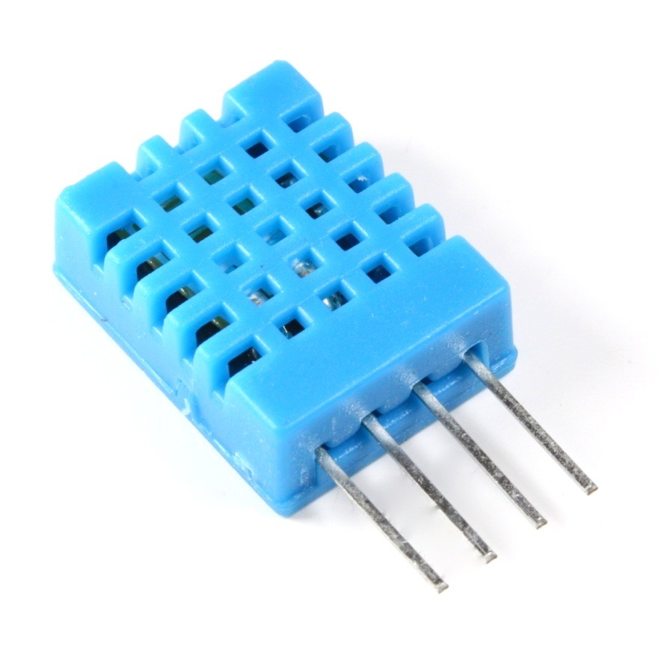

**DHT11** air temperature and humidity sensor,

temperature accuracy 2%, RH accuracy 5%

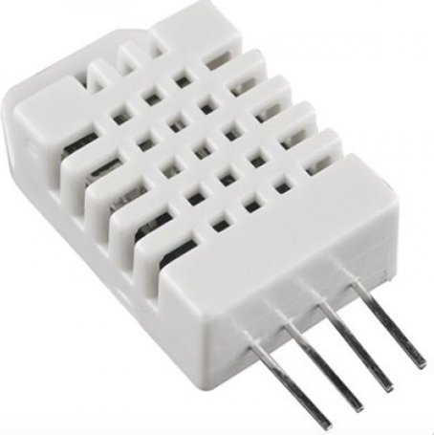

**DHT22** air temperature and relative air humidity sensor

temperature accuracy 0.5%, RH accuracy 2%

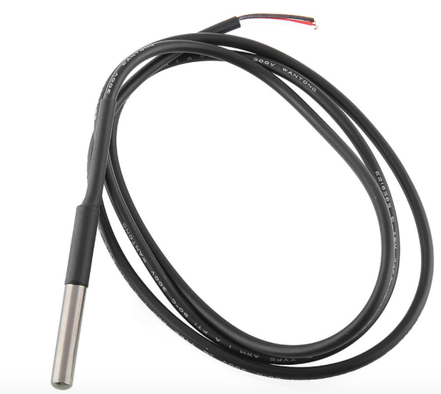

**DS18b20** waterproof 0.5% accurate digital temperature sensor

3 wire interface (Red =Vcc, Black =ground, Yellow=data out)

Future sensors to be tested:

Water pressure sensor 200 PSI, requires 5V boost DC/DC converter

MPXV6115V -115 to 0 kPa, Gauge and Absolute Pressure Sensor

Anemometer wind speed, requires 12V boost DC/DC converter

The choice of sensors needs to be agreed when ordering, as the Vinduino R3 programming and Internet interface needs to be configured to support the selected sensors. Sensors can be added later, and the supporting software can be upgraded in the field.

## Sensor installation

The installation of sensors needs preferably be done at least two weeks before the anticipated activation of the remote sensor station.

The Vinduino project uses 4 soil moisture sensors at different depths per location to determine the percolation of irrigation water in the soil.

For wine grapes, the recommended installation depths are 1 foot, 2 feet, 4 feet, and 5 feet.

The sensor at 5 feet is to be considered below the active root zone, and should show low moisture levels as drainage of irrigation water below 4 feet is out of reach of the grapes.

Ideally, all sensors should be vertically aligned close to an irrigation dripper.

For easy maintenance and replacement, ¾ “ PVC pipe is recommended to mount and install the sensor at the desired depth. Keeping 1’ of pipe above ground helps avoid wildlife damage to the electrical wiring.

TIP:

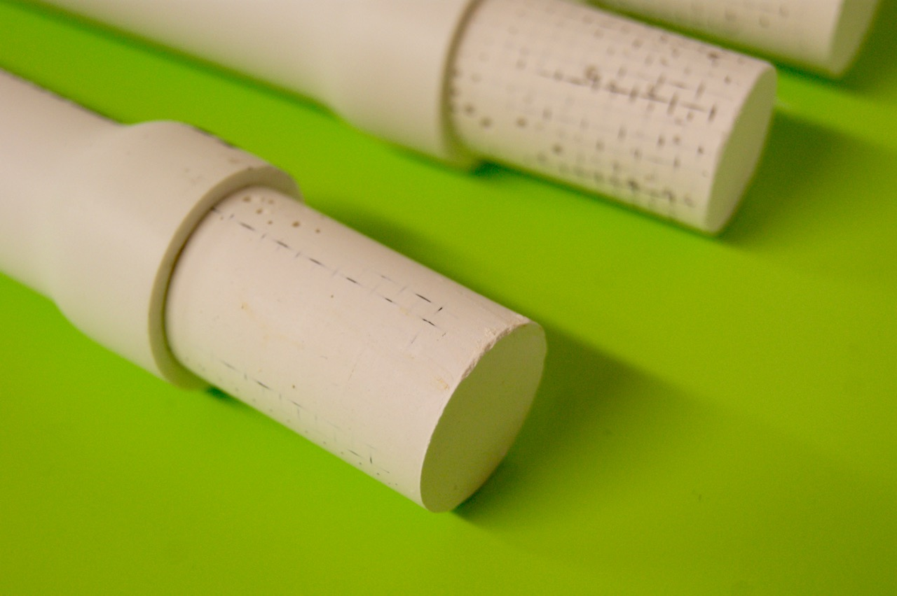For Vinduino gypsum sensors, PVC pipe can be widened after applying hot air with a heat gun. After inserting the sensor, re-heating with shrink the pipe to tightly fit around the sensor.

Gypsum sensors need a good soak before installation in the soil. To ensure good soil contact, put some soil slurry in the hole and make sure that the sensor is well settled into the slurry before filling up with soil.

Link to sensor installation guidelines: <http://mea.com.au/upload/new/product_brochures/b83_soil-moisture_sensor_installation_guide_web.pdf>

According to Australian sources, gypsum sensors can have a useful life of 3-5 years.

The gypsum slowly dissolves in water, so actual product life depends on the moisture level.

# Vinduino R3, remote sensor station

## Solar power

The remote sensor station is designed for continuous unattended operation. It is powered by a small solar panel, and the battery charger keeps the battery fully charged to keep the system working during the night and during periods with dense cloud cover. A green LED on the electronics board indicates that the charger is operational.

The battery voltage is measured and sent together with the sensor data. A healthy battery should provide a voltage between 4.2V and 3.6V. Below 3.6V, the battery is close to empty.

The battery connector is also used to switch the system on or off. Disconnect the solar panel before disconnecting the battery to avoid the system continuing on solar power.

Important: the solar panel is connected to the wire terminal block. The red wire connects to the “+”, and the black wire connects to the “-“. Connecting the solar panel with the wires with reversed polarity will damage the battery charging chip.

## Connecting sensors

The Vinduino R3 has inputs for 4 soil sensors. The soil sensor wires connect to the wire connection block. Sensor 1 wires are connected on the right side. The type of wiring is not critical for the accuracy or performance of the soil moisture measurement.

The printed circuit board is designed to support a DHT11 or DHT22 sensor (temperature and relative humidity). These sensors are not waterproof and can only be used for measuring inside the enclosure.

For temperature measurement outside the enclosure, soil or air temperature, a waterproof temperature sensor like the DS18b20 can be used.

Other sensors can be attached using the “Accessories” connector on the electronics board. This connector gives access to 2 digital pins, an analog input, and a switched 3.3V power supply pin that can be used for sensors that require electric power.

Future use of the accessories connector is to control an irrigation valve and water pressure sensor.

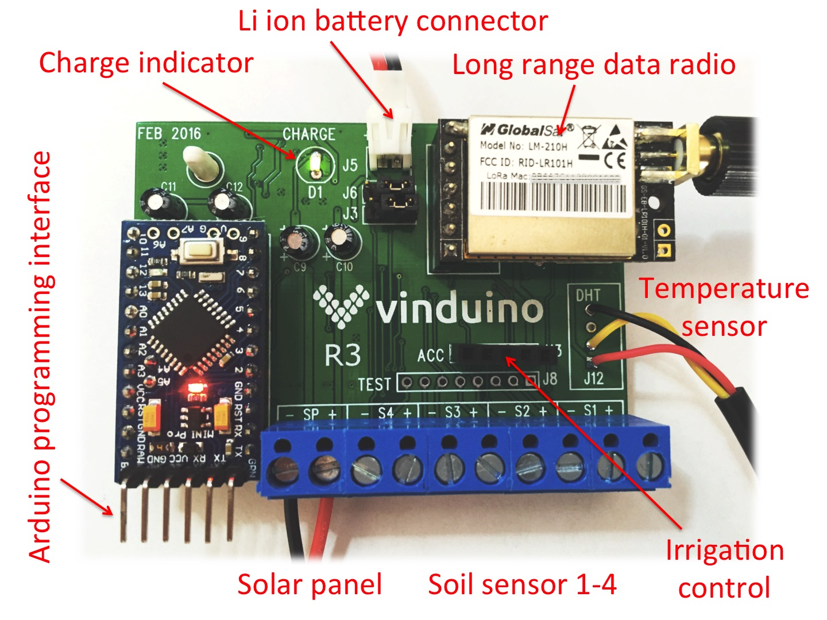

## Timer

The Vinduino R3 has an integrated clock chip that is used to wake up the system from power saving sleep mode. After the Vinduino is done with making measurements and transmitted the measurement data, it goes back to sleep again.

During the active mode, a green LED on the Arduino board lights up.

Typically, the timer is programmed for 15 minutes or one hour. When many remote sensor stations share one gateway, it is better to have longer interval times to avoid “crowding” of the radio frequency.

The timer can also be used (future) for precision irrigation timing, or keeping system time.

## LM-210 radio module

The telemetry radio unit used in the Vinduino project follows the recent LoRa standard, which allows long range wireless networking. The unit is FCC approved in the USA for license-free use in the 915 MHz band.

Range is dependent on the conditions. With the supplied antennas typically 1-3 miles is possible. With line-of-sight and external antennas, considerable longer distances are possible.

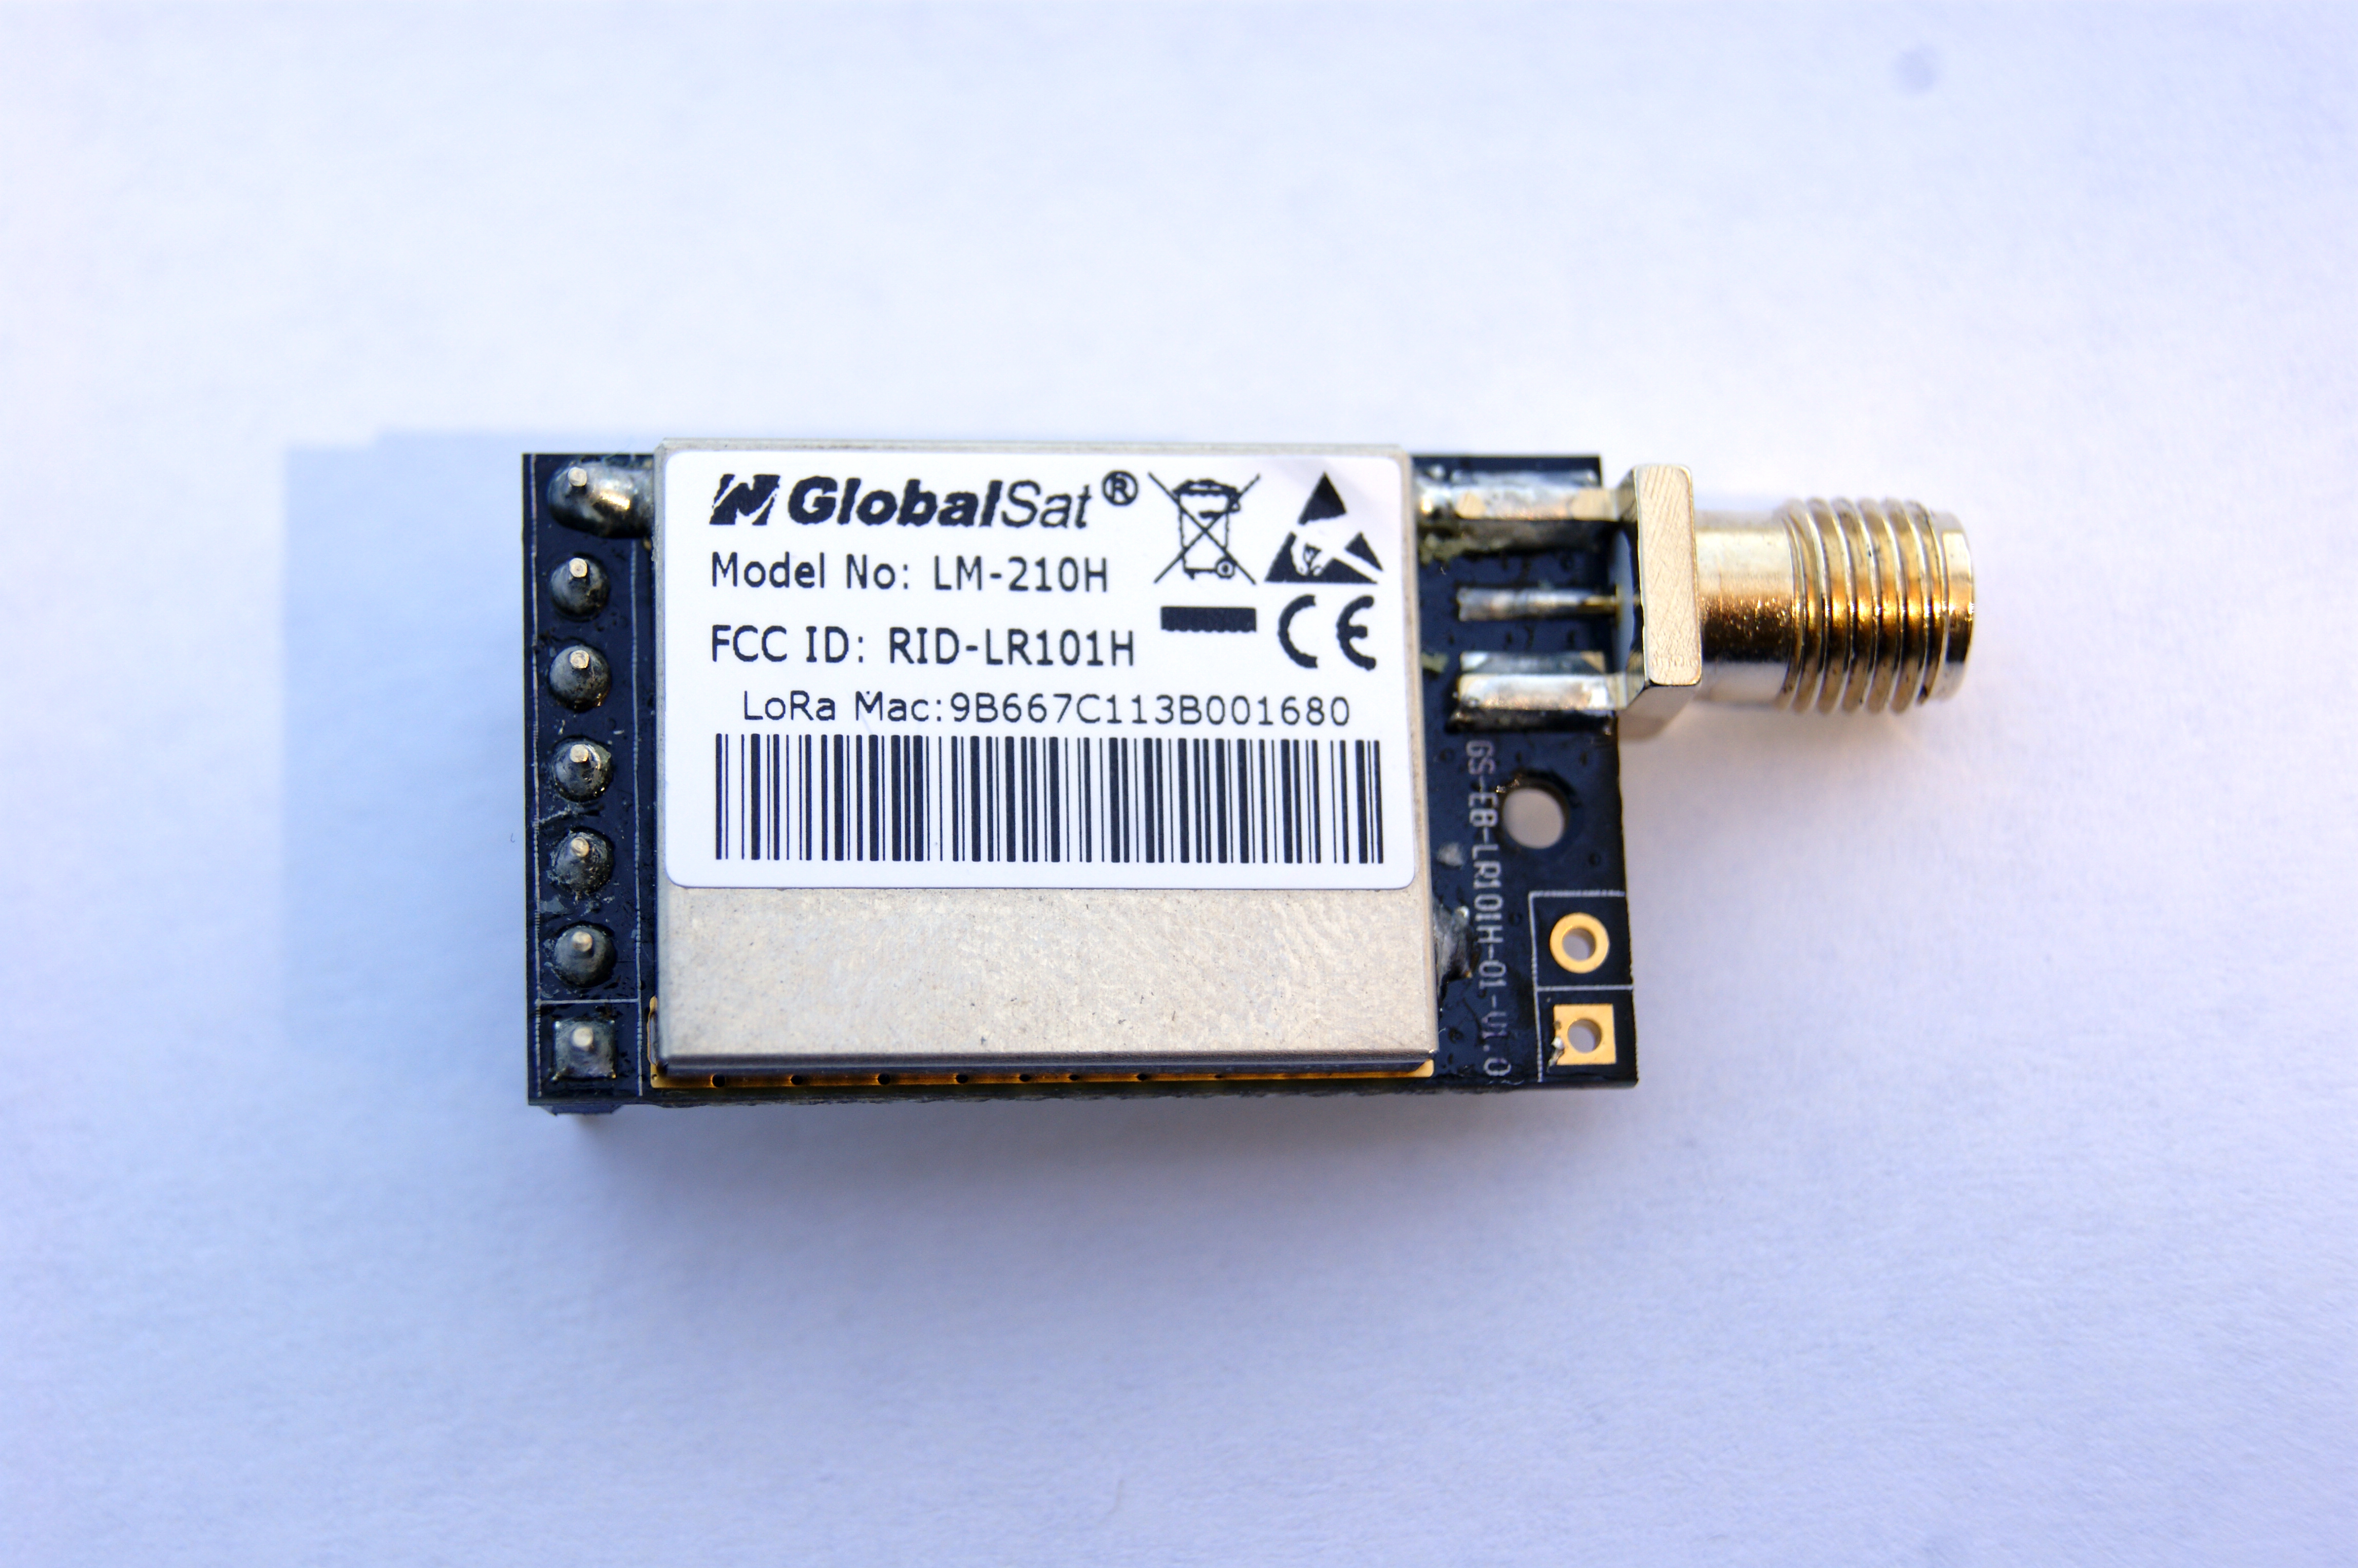

The unit can be re-programmed for different output power levels and frequency. The default settings are 915 MHz and 100mW power.

Frequency change is only needed in vase of strong local interference from other users of the frequency or in case of installation in Europe where 868MHz is used for LoRa.

The LM-210 module works on 3.3V and the Vinduino board is designed for that. Before programming the Arduino microcontroller board with a USB adapter cable, the LM-210 module should be removed to avoid USB level voltages (5V) reaching the module.

## Programming

In order to change the program code of the Vinduino, for instance to change the wake up time or change sensors, you will need a programming cable and Arduino PC software.

The USB programming cable is needed to connect to a PC

Please use the 3.3V version of the cable: http://amzn.com/B00DJBPIGI

Do not forget to remove the radio module before connecting the cable.

Arduino programming software is available for free for most recent computer operating systems: <https://www.arduino.cc/en/Main/Software>

Vinduino programming code is available for download via Github: <https://github.com/ReiniervdL/Vinduino>

## Vinduino R3 installation

The remote sensor station comes as a watertight NEMA enclosure. Sensor cables should enter the enclosure using a NEMA rated cable gland (supplied).

The unit can be mounted at an angle for the solar panel to get best exposure to the available sunlight. Best direction for the solar panel is facing South.

The Vinduino R3 sensor unit comes preprogrammed for your personal ThingSpeak channel, and should connect to the gateway without need for any settings.

TIP: It is recommended to spray paint the transparent cover partially white to keep the temperature inside the enclosure lower. Leave the solar panel area clear.

This will enhance the life of your battery.

# Vinduino Gateway V1

The Gateway receives telemetry signals from the Vinduino sensor stations, and sends it in the proper format via WiFi to the ThingSpeak website on the Internet. We envision that access to a Vinduino Gateway can be shared among many users.

## Vinduino Gateway Installation

The setup of the Gateway is done using a so-called “Blink Up” of the integrated Electric Imp WiFi module. This requires local support from the Vinduino team. In the future we hope to make this more consumer friendly.

Once the set up is completed, all maintenance and performance checking can be done remotely.

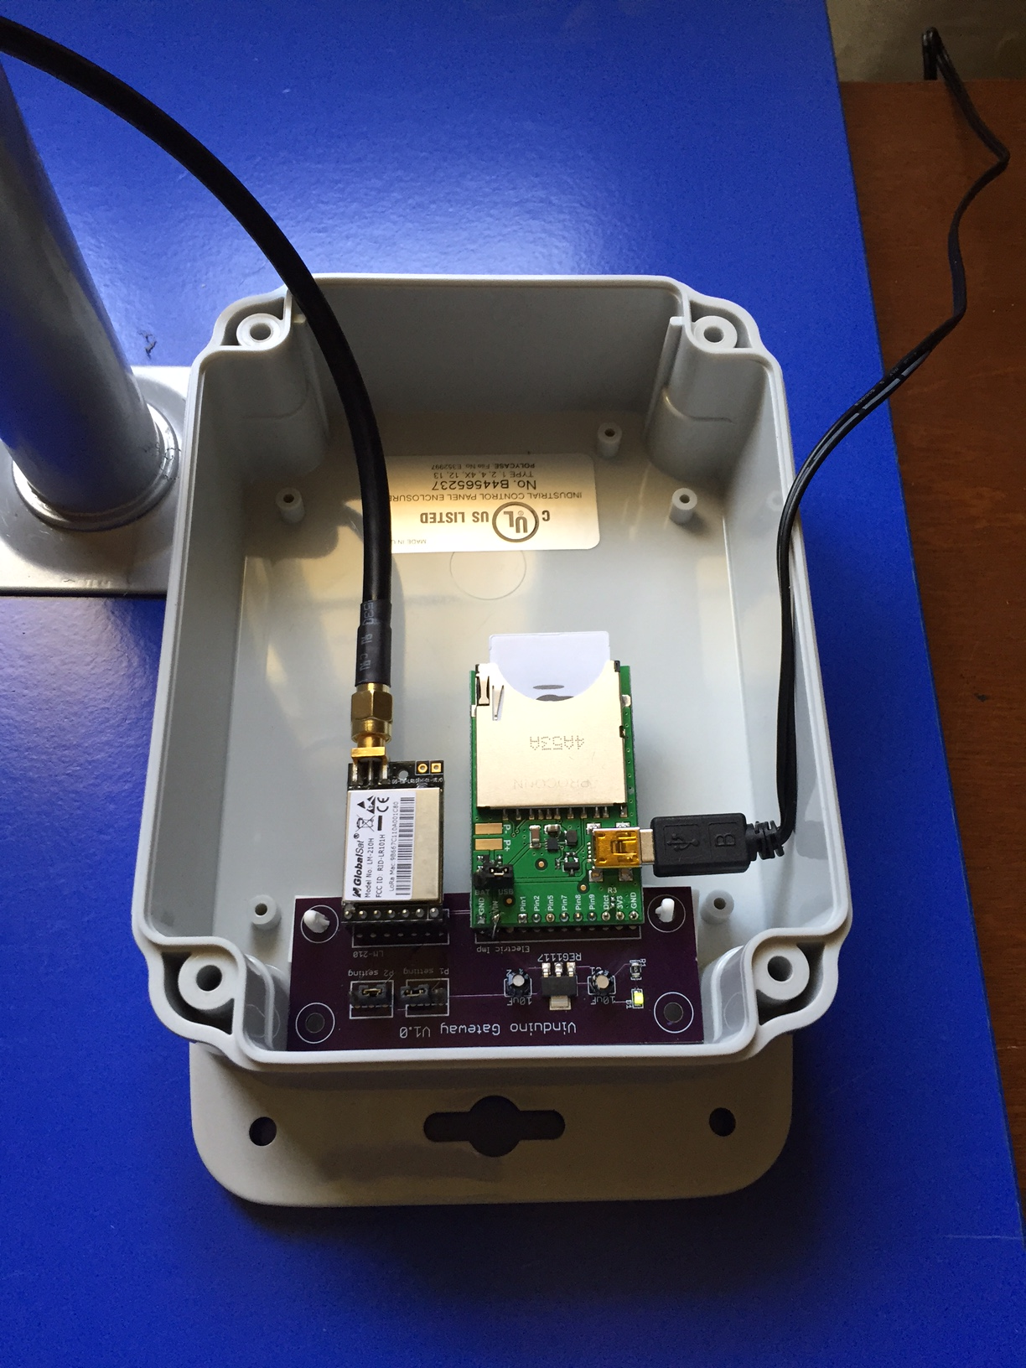One single gateway can receive data from many stations. The reception range depends on the local conditions and placement of the gateway.

It is always preferred to have the Vinduino Gateway installed at a high and free outside location. Using an external antenna also improves the general performance of the system. The Vinduino Gateway is remotely programmed and maintained. It only requires power and a working WiFi connection. Vinduino telemetry data rates are very low. Adding the gateway to your WiFi network should not impact your WiFi performance.

# ThingSpeak website

The gateway forwards your sensor data to the ThingSpeak web site. You need to set up a free account for the ThingSpeak server to recognize your sensor data.

Go to [www.thingspeak.com](http://www.thingspeak.com)

sign up, and create a channel for each sensor station.   
A channel is where you store and can see your vineyard data on-line.

The Thingspeak "channel number" that is assigned to you and the "API write key” will be programmed in your unit ahead of installation. Please forward this info to us.

After that is done, we will program and test your unit for a few days, so everything should work out of the box.

Other ways to access and view your data:

Here is a HTML JavaScript web page to display multiple series and channels in real time.

<http://forum.arduino.cc/index.php?action=dlattach;topic=213058.0;attach=66726>

You must edit the page source/ JavaScript to enter your channel information.

If you have lots of series, it is helpful to click the "Hide All" button, and then click on the series names you are interested in to show them. Clicking and dragging vertically on the chart will select a range to zoom in to.

View your data on an Android device:

<https://play.google.com/store/apps/details?id=com.cinetica_tech.thingview>